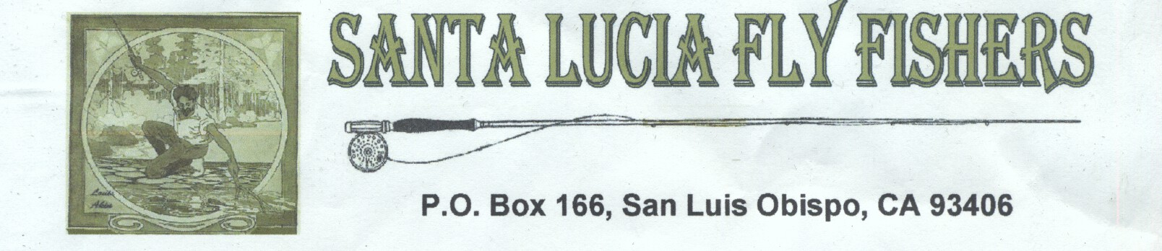
ANNUAL BANQUET INVITATION

Saturday March 12,2022 12:00-3:30PM

Madonna Inn San Luis Obispo

Please plan to join us for our Annual Banquet and Fundraiser. Our guest speaker will be Kesley Gallagher. Check out her biography at
https://bdoutdoors.com/kesley-gallagher-bd-fishing-chick/
You don’t want to miss meeting her and hearing about her fly fishing experiences around the world. With numerous IFGA fly fishing records to her credit, her program will be sure to please.
Lunch will be served; your choices are below. Cost will be $33 per person. There will be a no host bar, raffle and silent auction. Raffle tickets are 6 for $5. If you can’t attend please help support your club and by purchasing some raffle tickets. You may win some great prizes and need not be present to win.
Guide trips, auction items, and raffle prizes are coming in from generous donors. As you know from past banquets, the prizes are awesome. You won’t be disappointed!
Payment includes lunch, tax, tip and speaker. You can prepay for your meal(s) and/or raffle tickets on our new website https://www.santaluciaflyfishers.com or by sending your payment with the registration form below to:
Santa Lucia Fly Fishers
P O Box 166
San Luis Obispo CA 93406
In either case, we need to receive your reservation information and payment no later than February 28, 2022, either online through our new club website, or delivered to the club P.O. Box. Your prepaid tickets will be held at the door. Lunch tickets cannot be sold at the door.
-----------------------------------------------------------
Name_____________________ ___ Total Meals @ $33 $_____
Address___________________ ___ Raffle Tickets $_____
City, State, Zip_____________
Telephone_________________ Total Enclosed $_____

Meal choices: __ Roast Sirloin of Beef, __ Petite Monterey Salmon Filet, __ Vegetarian Lasagna

